Eliminate dead code

AIM
To write and execute a C program to perform dead code elimination on Three Address Code (TAC) statements by identifying live statements and removing statements whose results are not required.

SOFTWARE REQUIRED
Software: Dev-C++
Programming Language: C

PSEUDOCODE
Step 1: Start the program.
Step 2: Declare arrays to store the TAC statements, left-hand-side variables, right-hand-side expressions, and liveness flags.
Step 3: Read TAC statements one by one until END is entered or the maximum number of statements is reached. Ignore empty lines.
Step 4: For each statement, locate the assignment operator (=). If present, separate the left-hand-side variable from the right-hand-side expression.
Step 5: Initially mark all statements as not live.
Step 6: Traverse the statements in reverse order, from the last statement to the first.
Step 7: Preserve statements with destinations that must remain externally visible, such as x and y. Also preserve statements without an assignment if any are entered.
Step 8: Check whether the result of the current statement is needed by a later live statement. If it is needed, mark the current statement as live.
Step 9: For every live statement, scan its right-hand-side expression to identify variable names.
Step 10: For each variable used by a live statement, search backward for its most recent earlier definition and mark that definition as live.
Step 11: After processing all statements, print only the statements marked as live under the heading Optimized Three Address Code.
Step 12: Stop the program.

OUTPUT
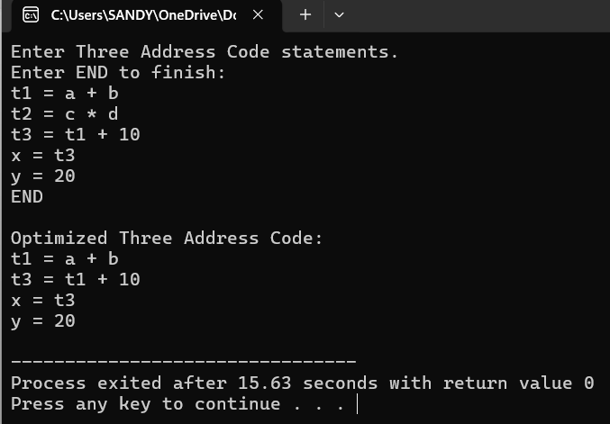

RESULT
Thus, the C program was successfully executed in Dev-C++ to perform dead code elimination on Three Address Code (TAC) by identifying and displaying live statements while removing statements considered unnecessary.

